Activity 3: Bookshelf Management System
Title: Bookshelf Management System with NestJS Backend and React Frontend

Short Description
This application is a comprehensive bookshelf management system that allows users to manage a digital library of books, authors, and categories. The system provides a modern web interface for browsing, searching, and managing book collections, with a robust REST API backend for data operations.

Key Features:
- Book Management: Add, view, edit, and delete books with detailed information
- Author Management: Manage author profiles and their associated books
- Category Management: Organize books by categories (Fantasy, Science Fiction, Horror, etc.)
- Search & Filter: Find books by author, category, or other criteria
- Responsive UI: Modern, mobile-friendly interface built with React and TypeScript
- REST API: Complete CRUD operations with Swagger documentation
- Database: SQLite database with seeded sample data (50 books, 10 authors, 10 categories)

Screenshots of Working System
Frontend UI Screenshots
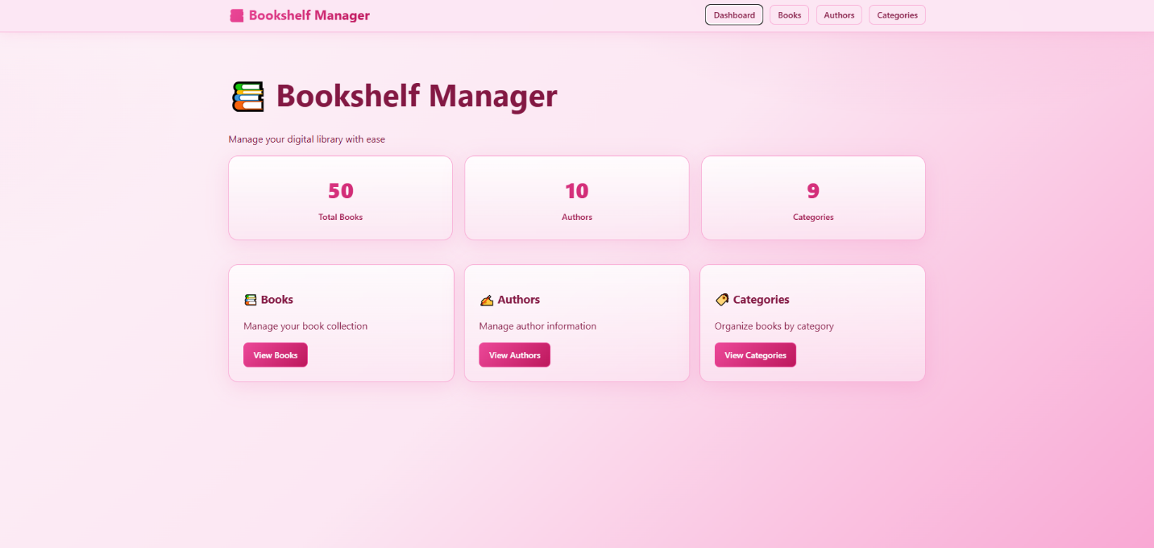

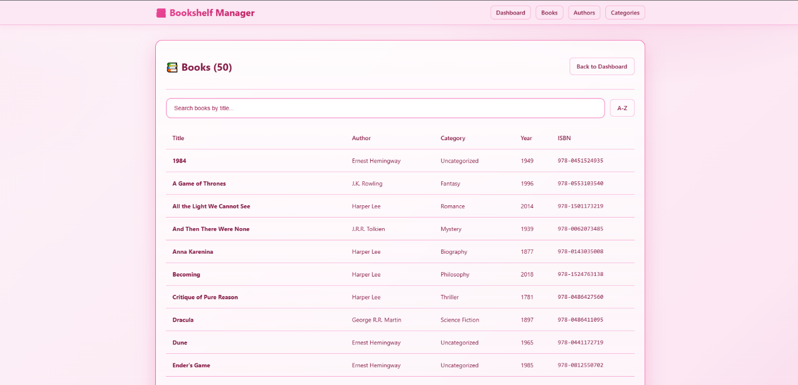

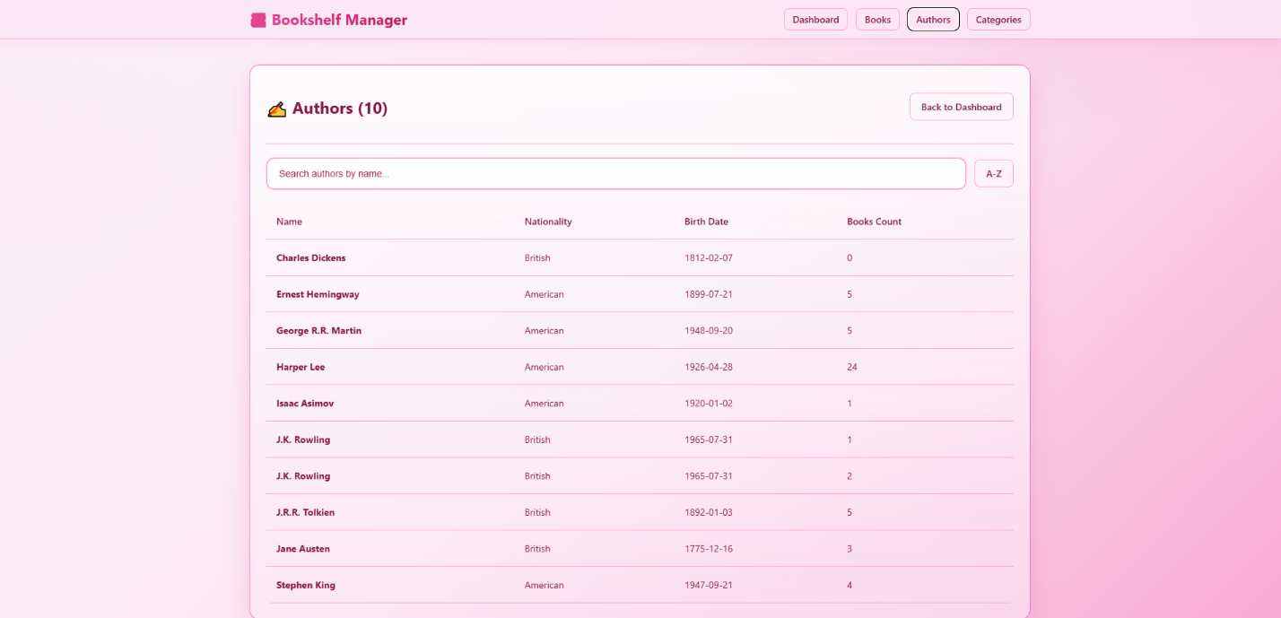

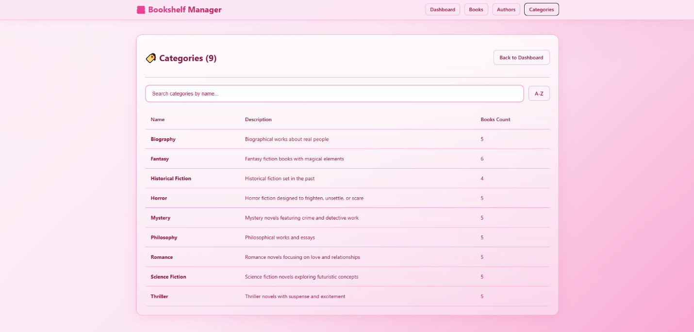

API Documentation (Swagger):
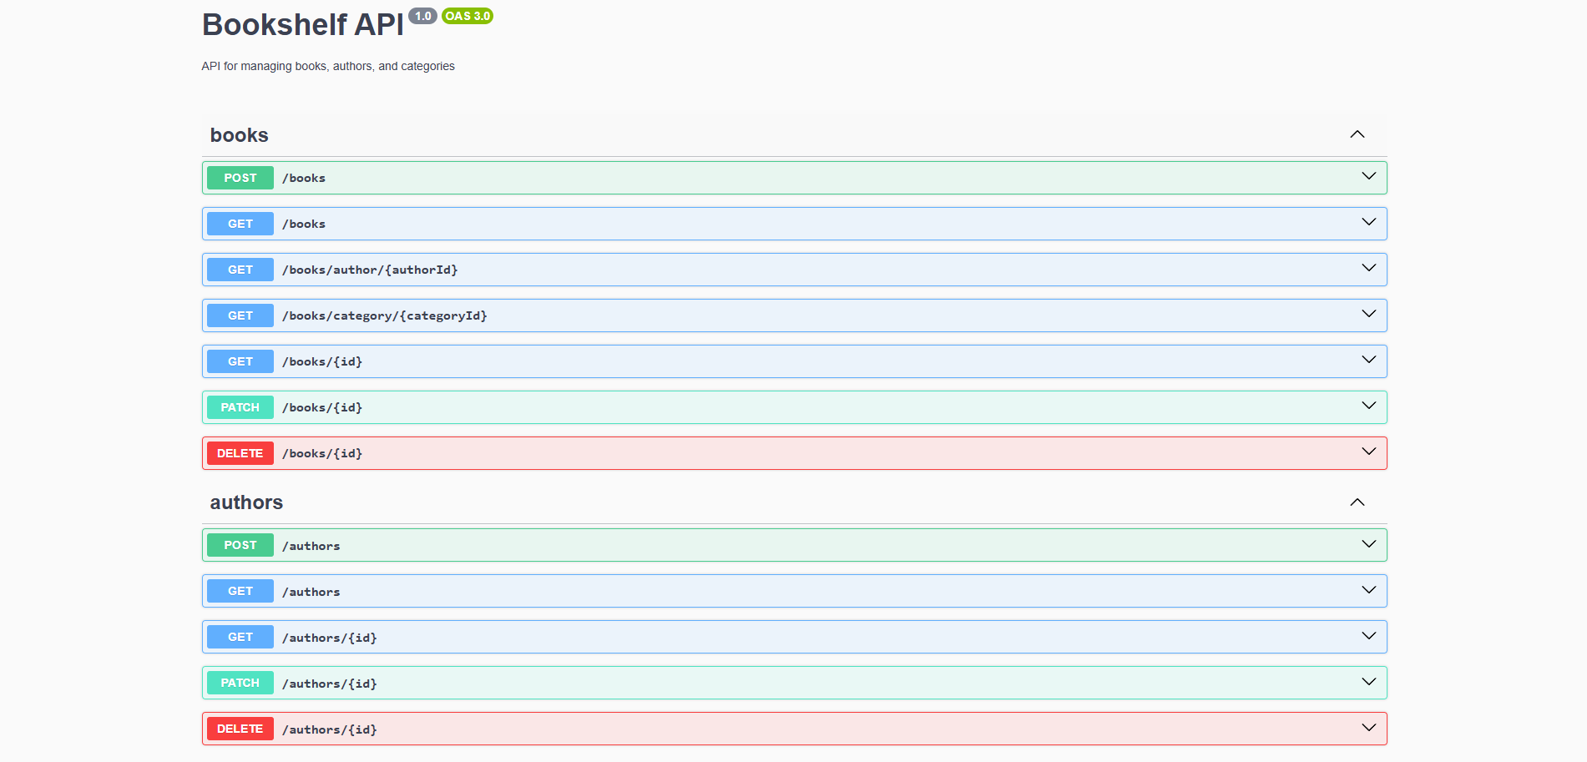

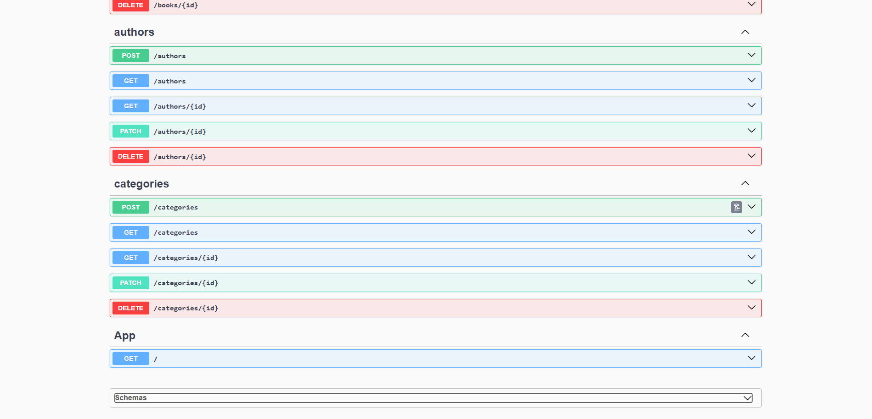

GET /books Response:
```json
{
"data": [
{
"id": 1,
"title": "Harry Potter and the Philosopher's Stone",
"isbn": "978-0747532699",
"publicationYear": 1997,
"author": {
"id": 1,
"name": "J.K. Rowling"
},
"category": {
"id": 1,
"name": "Fantasy"
}
}
],
"total": 50,
"page": 1,
"limit": 10
}
```

Instructions on How to Run the Project
Prerequisites
- Node.js (version 16 or higher)
- npm (Node Package Manager)
- Git (for cloning the repository)

Step-by-Step Instructions
1. Navigate to the Project Directory
```bash
cd C:\Users\czyre\Group-4A-Repository\Activity3
```

2. Install Backend Dependencies
```bash
cd backend
npm install
```

3. Set Up the Database
The database will be automatically created when you start the backend. To populate it with sample data:
```bash
node seed-data.js
```

4. Start the Backend Server
```bash
npm run start:dev
```
The backend will start on `http://localhost:3000`
- API Documentation: `http://localhost:3000/api`
- Health Check: `http://localhost:3000`

5. Install Frontend Dependencies (New Terminal)
Open a new terminal/command prompt and navigate to the frontend directory:
```bash
cd C:\Users\czyre\Group-4A-Repository\Activity3\frontend
npm install
```

6. Start the Frontend Development Server
```bash
npm run dev
```
The frontend will start on `http://localhost:5173`

7. Access the Application
- Frontend: Open your browser and go to `http://localhost:5173`
- Backend API: Access the API at `http://localhost:3000`
- API Documentation: View Swagger docs at `http://localhost:3000/api`

MEMBERS
ABELITA, CZYRELL GWEN R.
ARANZASU, DARRYL
ARANZASU, DARRYLENE
MORAL, ANDREI
GANGAN, DEMROSE CARLA
RELOX, NATHANIEL

